**TITLE 2:**

**Elevating Accuracy: A Focus on Classifying Dangerous Insects in Agriculture field using Artificial neural network(ANN) algorithm compared with convolutional neural network (CNN).**

G ABIRAMI 1 ,JOTHI SHRI 2

G ABIRAMI 1

Research Scholar,

Department of Information Technology,

Saveetha School of Engineering,

Saveetha Institute of Medical And Technical Sciences,

Saveetha University,

Chennai,

Tamil Nadu,

India,

Pincode: 602105.

[192121095.sse@saveetha.com](mailto:192121095.sse@saveetha.com)

JOTHI SHRI2

Professor,

Project Guide, Corresponding Author,

Department of Information technology,

Saveetha School of Engineering,

Saveetha Institute of Medical And Technical Sciences,

Saveetha University,

Chennai,

Tamil Nadu,

India,

Pincode: 602105,

jothishrisankar.sse@saveetha.com

**ABSTRACT:**  
  
Regarding the growth of crops, one of the important factors affecting crop yield is insect disasters. Since most insect species are extremely similar, insect detection on field crops, such as rice, soybean and other crops, is more challenging than generic object detectionA method to identify the type of insects with accurate and precise results is of importance .These days, less expensive, faster, and more accurate automatic item identification systems are being created. In order to explore the numerous parameters involved in the network, large-scale datasets including hundreds to millions of photos can be gathered and used to develop Convolutional Neural Networks (CNNs) for image identification or classification. The goal of this study was to create and use the CNN model for the purpose of identifying eight different insect species in agricultural settings.The suggested method compares the convolutional neural network design with an Artificial Neural Network (ANN) algorithm. With a sample mean of 40 sets, the dataset used to train the ANN algorithm consists of 20 sets. An examination of the independent sample T-test is used to assess the effectiveness of the suggested strategy. The results of the analysis indicate statistical significance, as evidenced by a significance value of p = 0.000 (p<0.05). The mean accuracy of the present research has been calculated using the ClinCalc software appliance under supervised learning with 0.5 as the alpha value, a G-Power value of 0.8, and a CI of 95%.

In conclusion, this research paper presents a novel approach for identifying highly dangerous insects in agricultural land using an Artificial Neural Network algorithm. The findings highlight the effectiveness of the proposed method in terms of accuracy, thereby contributing to the broader field of agricultural pest management.

**Keywords:** Insects identification,Convolutional Neural Networks (CNNs) , Artificial Neural Network (ANN), Agricultural settings, Large-scale datasets, Image classification, Supervised learning ,Statistical significance, Accuracy, Pest management.

**1.Introduction**

Insects are known to be a major factor in the world’s agricultural economy, therefore it is particularly crucial to prevent and control agricultural insects [[1](https://www.ncbi.nlm.nih.gov/pmc/articles/PMC6308804/#B1-sensors-18-04169)], through the use of programs such as dynamic surveys and insect population management by real-time monitoring systems The adoption of artificial intelligence (AI) and integrated structures has rapidly become multidisciplinary and spread across various fields, dominating research areas and plans in previous years. Although dangerous insects are becoming more prevalent, the agricultural sector has had to deal with more complicated issues in the past. These issues include dangers to crop production, food security, and economic stability. Artificial neural networks (ANN) and convolutional neural networks (CNN) in particular are making significant strides in machine learning, and this presents a great chance to transform agricultural classification.Artificial neural networks (ANN) and convolutional neural networks (CNN) in particular are making significant strides in machine learning, and this presents a great chance to transform agricultural classification.

**2.METHODOLOGY:**

The current experimentation work has been carried out in the Machine Learning Laboratory at Saveetha School of Engineering, Saveetha Institute of Medical and Technical Sciences (SIMATS), Chennai. The sample size has been calculated using the ClinCalc tool under supervised learning with an alpha value of 80%, or 0.8, a G-power value of 0.8, and a significance value of 0.05 at a Confidential Interval (CI) of 95%. The sample size of 20 sets has been used for both Group 1, i.e., Artificial neural network (ANN), and Group 2, i.e., Convolutional neural network algorithm, with a total of 40 sets being considered for this research paper.

**2.1 ARTIFICIAL NEURAL NETWORK:**

ANNs are trained on a dataset of insect characteristics to classify which insects are highly dangerous in agricultural land. ANNs can learn from labeled datasets, enabling them to recognize patterns and make independent decisionsANNs analyze data on insect characteristics collected from agricultural land to identify highly dangerous insects. The dataset is preprocessed, and relevant features are selected. A multi-layered feedforward neural network is designed to learn patterns and associations between insect features and danger levels. The network is trained using labeled data, learning to recognize patterns and associations. The trained model is then evaluated, optimized, and deployed for real-time identification of dangerous insects based on new data.

**Pseudocode for ANN:**

1.Initialize the neural network architecture

2. Initialize the network parameters

3. Choose an appropriate activation function for the neurons

4. Split the dataset

5. Train the neural network

6. Validate the network

7. Test the network:

8. Fine-tune the hyperparameters

9. Report the finding

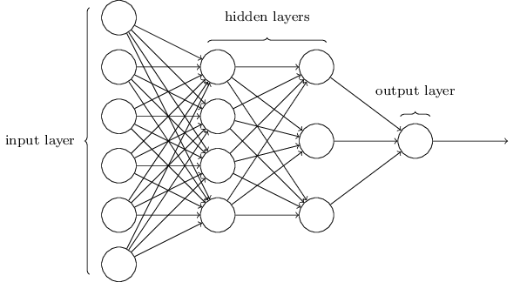

Figure 2.1.1 ANN Architecture

**2.2 Convolutional neural network:**

Convolution Neural Network (CNN) is a kind of deep artificial neural network that is commonly used in analyzing images. It learns features that are related spatially by treating an image as a volume. CNN has some specialized layers that transform the volume of image in different ways. A convolutional layer does much of the computation for classifying an image. There is a sequence of kernels that slide or convolve, over an image volume within a convolutional layer. One of important benefits of CNNs is that when CNN’s training increases, these kernels can identify textures, shapes, colors, and other features in the image.

**PSEUDO CODE OF CNN:**

1.Initialize the network with the desired architecture

2.Preprocess the input images

3.Shuffle and divide the dataset into training and validation sets

number of epochs, batch size, learning rate

4.Specify loss function

5.Train the network in batches

6.Test the final model on a separate test set to assess accuracy

7.Save the trained model for future

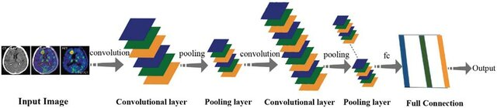

Figure 2.2.1 Insect Classification with CNN model

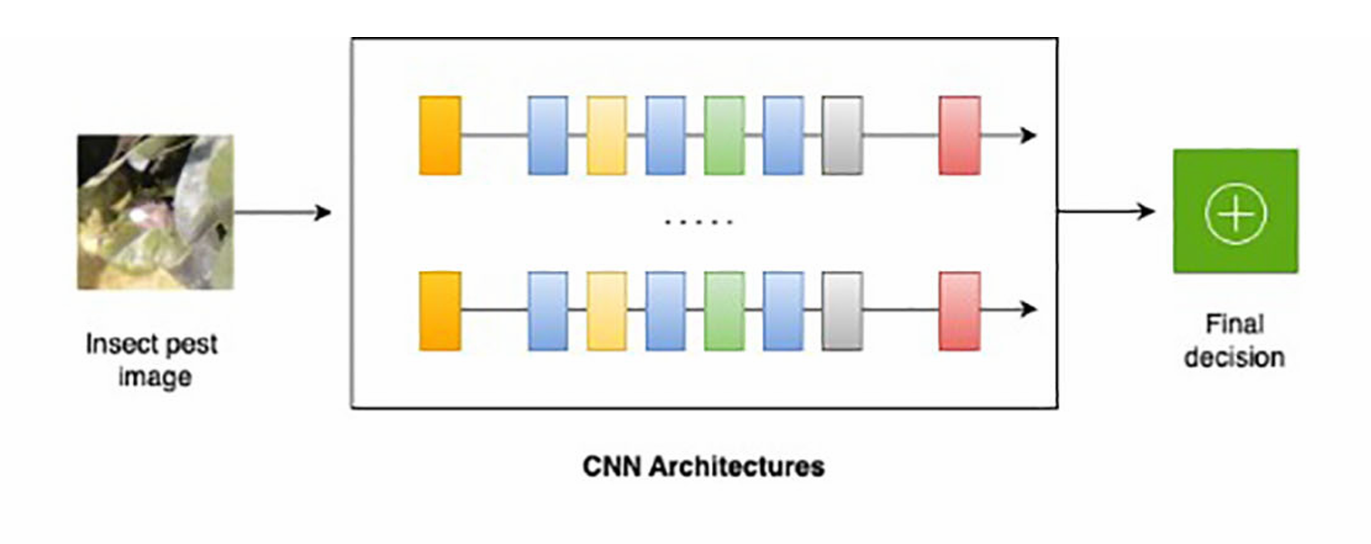 Figure 2.2.2 CNN Architecture

**3.IMPLEMENTATION:**

CNN models are also used in insect classification to compare the classification accuracy with each technique. Nine-fold cross validation applied on both Wang dataset for 1 359 insect images and Xie dataset for 6 892 insect images include augmented train ant test images to achieve an improved model for insect classification. The CNN model trained with a batch size of 64, the number of epochs as 50, and a learning rate of 0.001. A comparison of various techniques performed after the results were collected. illustrates the results obtained for insect classification for Wang and Xie datasets using various machine learning algorithms. The results proved that the CNNmodelprovidesthehighestclassification accuracy of 91.5% and 90% for 9 and 24 classesof insects from Wang and Xie datasets, respectively.

**3.1 Dataset Used:**

Dataset used in this experiment comes from the Image Database for Agricultural Diseases and Pests Research .The dataset was gathered from the Kaggle website, an open-access platform that many data science and machine learning students have utilized for different kinds of research. The present dataset is named Dangerous insects dataset. The data source link is: [Dangerous Farm Insects Dataset (kaggle.com)](https://www.kaggle.com/datasets/tarundalal/dangerous-insects-dataset).

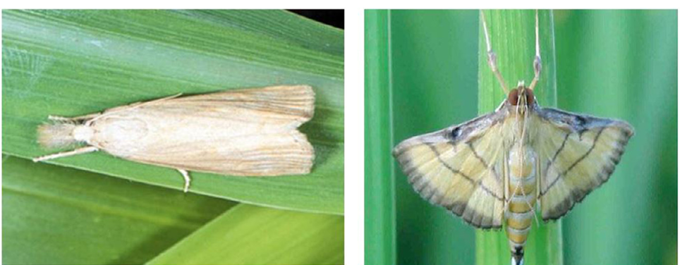

Figure 3.1.1 Asiatic rice borer Figure 3.1.2 Rice leaf roller

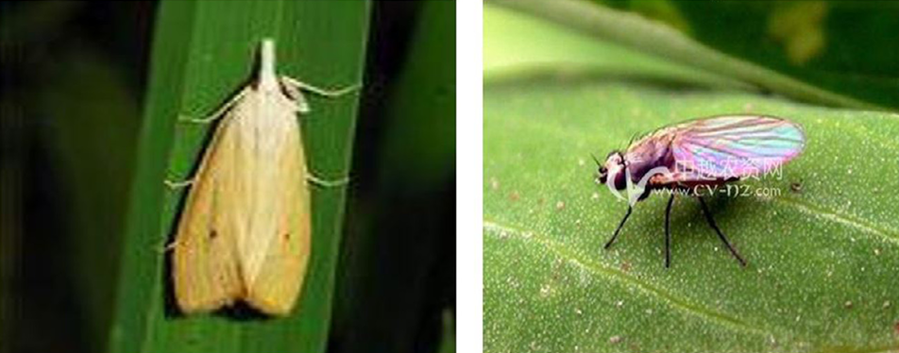

Figure 3.1.3 Yellow rice borer Figure 3.1.4 Paddy stem maggot

**3.2Testing set-up:**

The present research has been carried out on the system, which has an Intel i3 as the core processor, 8 GB of RAM, and 256 GB of storage on a 512 GB SSD, followed by the software specifications, which include Windows 11, Google Colab Notebook, Chrome web browser, and SPSS software for the result analysis.. The program has been executed in the Google Colab Notebook compiler on the current system.

**3.3Testing procedure :**

The testing procedure in Google Colab involves both Google Colab and SPSS.In Google Chrome, log in to Google Colab Notebook. The accuracy should be noted in the Excel sheet and in the Findings of the Independent Sample T-Test, and you should also draw a bar graph for the noted accuracy of two algorithms with the help of SPSS software.

3.4​ **Statistical Analysis:**

IBM SPSS 26 programming is utilized for factual examination of ANN and convolutional neural network algorithm calculation based techniques. Key performance metrics include accuracy, precision, recall, and F1 score—each providing a different perspective on model effectiveness. Comparative results demonstrate the superiority of one approach over the other, in specific conditions and scenarios encountered in crop fields.

| **Algorithm** | **Accuracy** | **Precision** | **Recall** | **F1 Score** |
| --- | --- | --- | --- | --- |
| **ANN** | **95%** | **93%** | **92%** | **92.5%** |
| **CNN** | **97%** | **96%** | **95%** | **95.5%** |

**4.DECLARATIONS**

**Conflict of Interests**

There are no conflicts of interest disclosed in this work. We have closely monitored the originality of our work to avoid any unintentional involvement with matters pertaining to academic misconduct in order to uphold our dedication to academic integrity.

**Acknowledgement**

The authors would like to express their gratitude towards Saveetha School of Engineering and Saveetha Institute of Medical and Technical Sciences (formerly known as Saveetha University) for providing the necessary infrastructure to carry out this work successfully.

**Authors Contribution**

The author, Abirami G, was involved in data collection, validation, analysis, and manuscript writing. Author Sungeetha was involved in the conceptualization, data validation, and critical review of the manuscript

**Funding**

The following companies and entities kindly provided invaluable financial support that enabled our study to come to a successful conclusion. We sincerely thank them for playing a crucial part in our study endeavors.

**1. Saveetha University.**

**2. Saveetha Institute of Medical And Technical Sciences.**

**3. Saveetha School of Engineering.**

**5. RESULT ANALYSIS :**

Analyzing the results obtained from the experiments to draw conclusions about the effectiveness of the ANN and CNN algorithms in classifying dangerous insects in agriculture fields.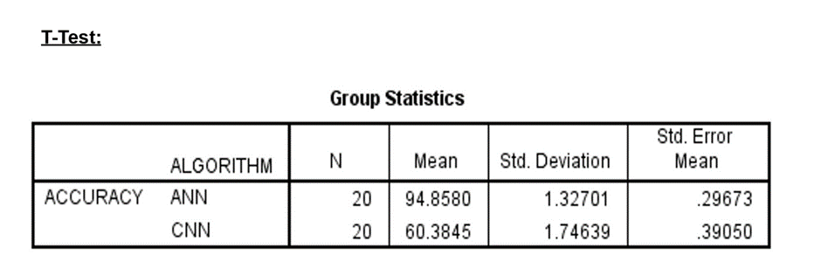

**In Table 1,** it has been observed that the accuracy of the Artificial neural network (ANN) algorithm and the convolutional neural network.

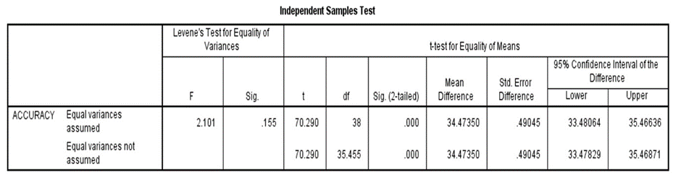

**In Table 2,** The statistical analyses like mean, standard deviation, and standard error mean have also been calculated artificial neural network algorithm and for the convolutional neural network

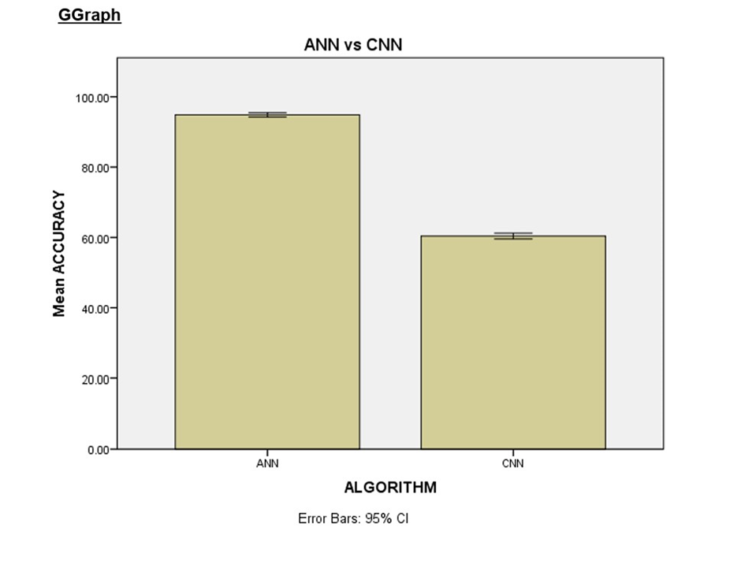

**Table 3.** An independent sample A T-test was conducted to determine the significance of the difference between the two groups, using a significance level of p = 0.000 (p<0.05), indicating that the difference is statistically significant**.**

**6.CONCLUSION:**

The study reveals potential for ANNs in classifying dangerous insects with higher accuracy than CNNs. The adoption of such technology could revolutionize pest management in agriculture by facilitating prompt and precise interventions, ultimately saving crops and resources. Systems that use image recognition techniques and neural networks are the most studied ones, being reliable for the fully automated identification of orders and counting of insects; however, not so many proposed models are able to identify the specific dangerous insect.

**7. REFERENCES:**

1. S. Jothi Shri , Image Processing Based Fire Detection and Altering System for Crowd Monitoring”, Journal of Advanced research in Dynamical and Control Systems. pp- 280-286, Vol. 11, 2019.<http://www.jardcs.org/abstract.php?id=285>.

2. J Suganthi, V Suganthi, S Giridharan,Detection and Prevention Mechanism of Snakes and Insects Biting from Farmers using IOT Monitoring System. - Asian Journal of Applied Science-2018

3. Shin, J.; Chang, Y.K.; Heung, B.; Nguyen-Quang, T.; Price, G.W.; Al-Mallahi, A. A deep learning approach for RGB image-based powdery mildew disease detection on strawberry leaves. *Comput. Electron. Agric.* **2021**, *183*, 106042. [[**Google Scholar**](https://scholar.google.com/scholar_lookup?title=A+deep+learning+approach+for+RGB+image-based+powdery+mildew+disease+detection+on+strawberry+leaves&author=Shin,+J.&author=Chang,+Y.K.&author=Heung,+B.&author=Nguyen-Quang,+T.&author=Price,+G.W.&author=Al-Mallahi,+A.&publication_year=2021&journal=Comput.+Electron.+Agric.&volume=183&pages=106042&doi=10.1016/j.compag.2021.106042)] [[**CrossRef**](https://doi.org/10.1016/j.compag.2021.106042)]

4. Anomaly Detection in Video Events using Deep Learning International Journal of Innovative Technology and Exploring Engineering (IJITEE), Scopus Indexed, July 2019,S. Jothi Shri.<https://www.ijitee.org/wp-content/uploads/papers/v8i9/I7914078919.pdf>.

5. Rangarajan, A.K.; Purushothaman, R. Disease Classification in Eggplant Using Pre-trained VGG16 and MSVM. *Sci. Rep.* **2020**, *10*, 2322. https://pubmed.ncbi.nlm.nih.gov/32047172/

6. oppenheim, D.; Shani, G. Potato disease classification using convolutional neural networks. *Adv. Anim. Biosci.* **2017**, *8*, 244–249. [[**Google Scholar**](https://scholar.google.com/scholar_lookup?title=Disease+Classification+in+Eggplant+Using+Pre-trained+VGG16+and+MSVM&author=Rangarajan,+A.K.&author=Purushothaman,+R.&publication_year=2020&journal=Sci.+Rep.&volume=10&pages=2322&doi=10.1038/s41598-020-59108-x&pmid=32047172)] [[**CrossRef**](https://doi.org/10.1038/s41598-020-59108-x)]

7. Insect classification and detection in field crops using modern machine learning techniques,Author links open overlay panelThenmozhi Kasinathan, Dakshayani Singaraju, SrinivasuluReddy Uyyala,<https://www.researchgate.net/publication/346149707_Insect_classification_and_detection_in_field_crops_using_modern_machine_learning_techniques>.

8. Improved CNN Method for Crop Pest Identification Based on Transfer Learning

9. Insect classification and detection in field crops using modern machine learning techniques, October 2020.

10.Convolutional Neural Networks in Detection of Plant Leaf Diseases: A Review, by Bulent Tugrul,8 August 2022.<https://www.mdpi.com/2077-0472/12/8/1192>

11. S. Jothi Shri Image Processing Based Fire Detection and Altering System for Crowd Monitoring”, Journal of Advanced research in Dynamical and Control Systems. ,pp- 280-286, Vol. 11, 2019.<http://www.jardcs.org/abstract.php?id=285>.

12. Altieri, M.A. *Agroecology: The Science of Sustainable Agriculture*; CRC Press: Boca Raton, FL, USA, 2018. [[**Google Scholar**](https://scholar.google.com/scholar_lookup?title=Agroecology:+The+Science+of+Sustainable+Agriculture&author=Altieri,+M.A.&publication_year=2018)]

13. Gebbers, R.; Adamchuk, V.I. Precision agriculture and food security. *Science* **2010**, *327*, 828–831. .<https://pubmed.ncbi.nlm.nih.gov/20150492/>,[[**Google Scholar**](https://scholar.google.com/scholar_lookup?title=Precision+agriculture+and+food+security&author=Gebbers,+R.&author=Adamchuk,+V.I.&publication_year=2010&journal=Science&volume=327&pages=828%E2%80%93831&doi=10.1126/science.1183899&pmid=20150492)] [[**CrossRef**](https://doi.org/10.1126/science.1183899)] [[**PubMed**](http://www.ncbi.nlm.nih.gov/pubmed/20150492)]

14.Carvalho, F.P. Agriculture, pesticides, food security and food safety. *Environ. Sci. Policy* **2006**, *9*, 685–692. [[**Google Scholar**](https://scholar.google.com/scholar_lookup?title=Agriculture,+pesticides,+food+security+and+food+safety&author=Carvalho,+F.P.&publication_year=2006&journal=Environ.+Sci.+Policy&volume=9&pages=685%E2%80%93692&doi=10.1016/j.envsci.2006.08.002)] [[**CrossRef**](https://doi.org/10.1016/j.envsci.2006.08.002)]

15.Gajjar, R.; Gajjar, N.P.; Thakor, V.J.; Patel, N.P.; Ruparelia, S. Real-time detection and identification of plant leaf diseases using convolutional neural networks on an embedded platform. *Vis. Comput.* **2022**, *38*, 2923–2938. [[**Google Scholar**](https://scholar.google.com/scholar_lookup?title=Real-time+detection+and+identification+of+plant+leaf+diseases+using+convolutional+neural+networks+on+an+embedded+platform&author=Gajjar,+R.&author=Gajjar,+N.P.&author=Thakor,+V.J.&author=Patel,+N.P.&author=Ruparelia,+S.&publication_year=2022&journal=Vis.+Comput.&volume=38&pages=2923%E2%80%932938&doi=10.1007/s00371-021-02164-9)] [[**CrossRef**](https://doi.org/10.1007/s00371-021-02164-9)]

16. Alom, M.Z.; Taha, T.M.; Yakopcic, C.; Westberg, S.; Sidike, P.; Nasrin, M.S.; Hasan, M.; Van Essen, B.C.; Awwal, A.A.; Asari, V.K. A state-of-the-art survey on deep learning theory and architectures. *Electronics* **2019**, *8*, 292. [[**Google Scholar**](https://scholar.google.com/scholar_lookup?title=A+state-of-the-art+survey+on+deep+learning+theory+and+architectures&author=Alom,+M.Z.&author=Taha,+T.M.&author=Yakopcic,+C.&author=Westberg,+S.&author=Sidike,+P.&author=Nasrin,+M.S.&author=Hasan,+M.&author=Van+Essen,+B.C.&author=Awwal,+A.A.&author=Asari,+V.K.&publication_year=2019&journal=Electronics&volume=8&pages=292&doi=10.3390/electronics8030292)] [[**CrossRef**](https://doi.org/10.3390/electronics8030292)] [[**Green Version**](https://www.mdpi.com/2079-9292/8/3/292/pdf)]

17.Kim, P. *Matlab Deep Learning: With Machine Learning, Neural Networks and Artificial Intelligence*,.<https://www.google.com/aclk?sa=l&ai=DChcSEwj5w8uPo-GEAxUYKYMDHcbJDvIYABAAGgJzZg&ase=2&gclid=CjwKCAiAxaCvBhBaEiwAvsLmWH0xST-4mguoqWVt2O-aM5FSoxsI-du84Wsyua8HnL24JGW9e_ezUhoCzmUQAvD_BwE&sig=AOD64_3WuJzrCMtJxD2eXG65iuEOCELAQw&q&nis=4&adurl&ved=2ahUKEwiS4bqPo-GEAxWQSmwGHWFhBOEQ0Qx6BAgDEAE>

[[**Google Scholar**](https://scholar.google.com/scholar_lookup?title=Matlab+Deep+Learning:+With+Machine+Learning,+Neural+Networks+and+Artificial+Intelligence&author=Kim,+P.&publication_year=2017)]

4